Participating Schools  We primarily seek students from Dundalk High School and its two feeder schools:  Dundalk Middle School and  Holabird Middle School  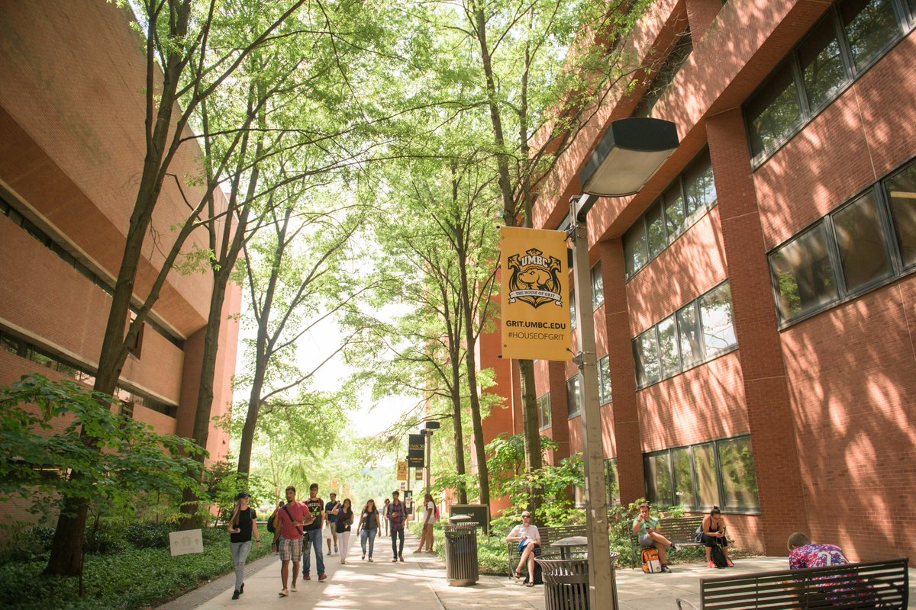  We may be able to service students who are not participating in another TRIO Program- if the student meets our requirements- please call if you wish to know more. |  |  | 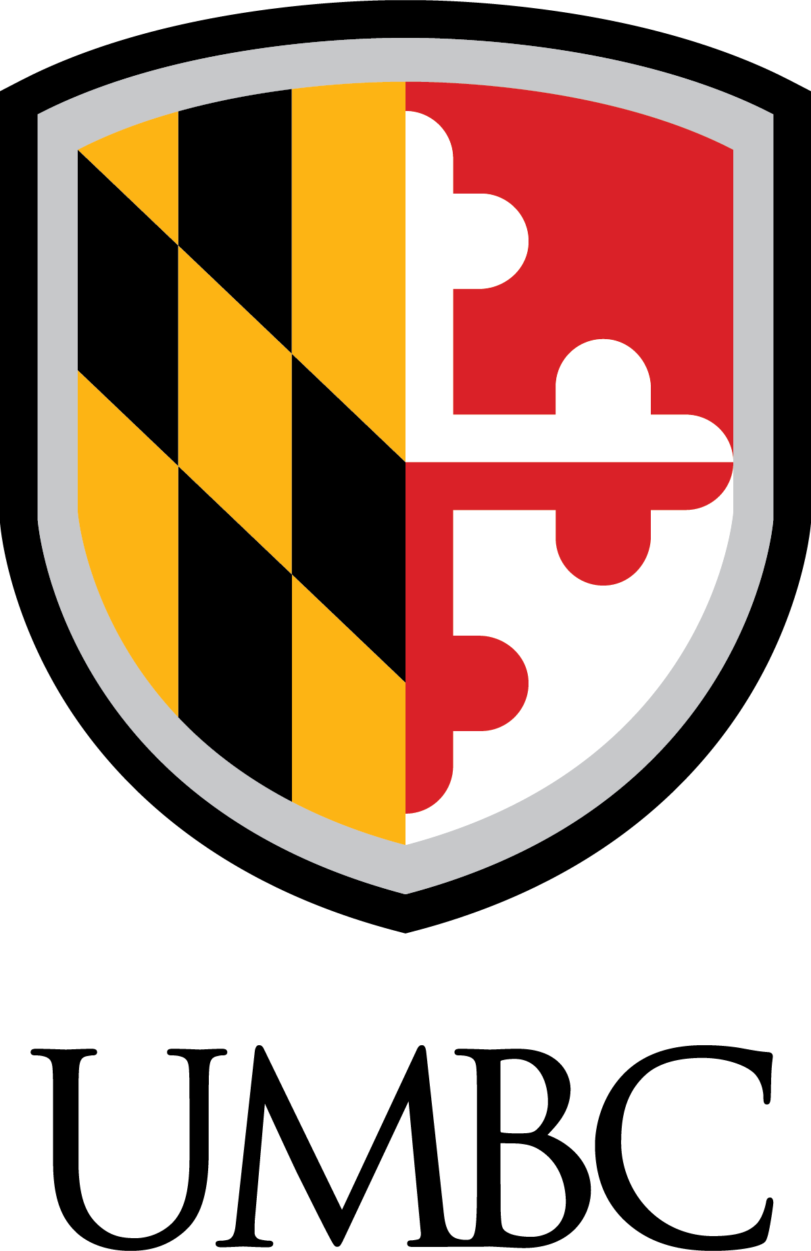  The UMBC Educational Talent Search Program is funded 100% by the  US Department of Education with a grant in the amount of $267,995.  Contact us for Information.  410-455-2901  410-455-1062 (Fax)  Email: talentsearch@umbc.edu  @talent_umbc    1000 Hilltop Circle  Math/Psychology Building  Room 010A  Baltimore, MD 21250  talentsearch.umbc.edu |  |  | Educational Talent Search Program  - talentsearch.umbc.edu

What is Educational Talent Search?  Educational Talent Search is a Federally Funded TRIO program that assists Baltimore County Public School System middle and high school students who wish to pursue a college education but feel they are facing financial and other challenges.    What is TRIO?  TRIO is a set of federally funded college opportunity programs that motivate and support students from disadvantaged backgrounds in their pursuit of a college degree. An estimated 790,000 students are served by over 2,800 programs nationally. TRIO programs provide an array of educational services and support necessary for educational access and retention. TRIO programs provide direct support services for students. The Educational Talent Search Program has been changing lives since 1965! |  |  | What We Do  The Educational Talent Search Program (ETS) provides free resources that will enhance individual academic success/ career awareness, cultural enrichment, and personal growth. We offer a variety of services which are available at no cost to eligible students at targeted schools in Baltimore County.  A Professional School Counselor at each school serves as the formal point of contact with the ETS Program. Principals at our target schools are generous in providing Talent Search Advisors/ Directors the support and flexibility to operate by way of: office space, administrative support from the guidance departments, access to classrooms and computer labs, the use of school facilities and equipment during and after school, and the prerogative to write hall passes and access the students. | The goal of the ETS Program is to increase the rate at which participants complete secondary education and enroll in and graduate from institutions of post-secondary education. |  | - Field trips to college campuses  (in and out of state)  - Educational activities  - Tutoring/tutoring referrals  - Cultural activities  - Academic Monitoring  - Student/parent workshops  - Summer Bridge Program for Middle  School Students    Who Can Participate:  - Individuals between the ages of 11-27  and  - U.S. Citizen OR Permanent Resident  and/or  - First Generation college bound students*  and/or  - Students meeting low income guidelines*  *Indicates that 1/3 of participants can be neither First Generation College Bound students nor Low Income.
Services We Provide

